Sample Letter for Schools to Promote Walking School Buses

Dear Parents,

As you know, we have been working for some time to reduce the traffic congestion around our school and promote safer and healthier alternatives. We have participated in International Walk to School Month and hold regular Walking Wednesdays. Our students and parents are to be congratulated for their efforts in supporting these important initiatives.

We would like to encourage families to walk to school on a more regular basis, rather than just on Wednesdays. We know some of you are already doing this and we thank you for setting a great example for the rest of us. To this end we are promoting Walking School Bus Week at our school, to be held [fill in dates here]. The attached flyer will give you more details on this program. If you are interested in participating in Walking School Bus Week, please complete the form on the back of the flyer and send it back to the school with your child.

It may not be possible for your family to walk every day, but if you can do it even two or three days a week that would be great. If we all do a little, we’ll achieve a lot!

Participating families will receive a kit that includes useful information on organizing a Walking School Bus, as well as ideas on how to make your daily walk safe and enjoyable.

Walking School Bus Week is an initiative of Green Action Centre’s Active and Safe Routes to School program. Green Action Centre coordinates this project across Manitoba and you can visit their website at www.greenactioncentre.ca to learn more.

Signed by Principal

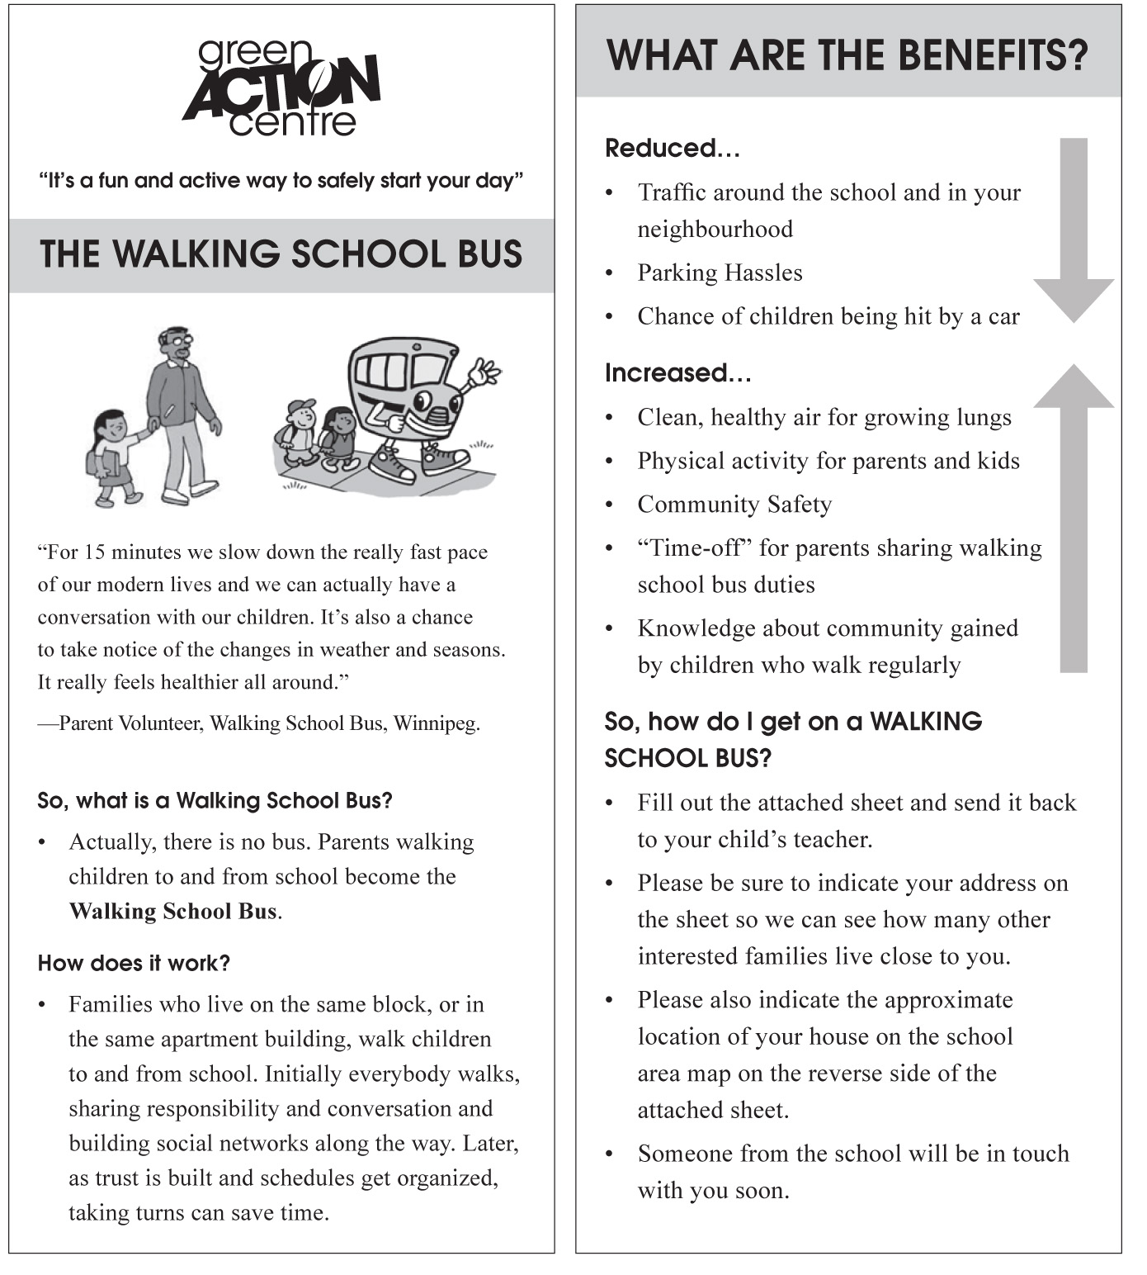



Your School
Logo Here!

If you are interested in trying a Walking School Bus for one week, please complete the questions below and send this back to your child’s teacher.

Your name: ___________________________________________

Your phone #: ________________________________________

Children’s names and grades (list them with the oldest first):

__________________________________________________________________

__________________________________________________________________

__________________________________________________________________

Street you live on: __________________________________________________

Nearest intersection to your house: _____________________________________

_________________________________________________________________

