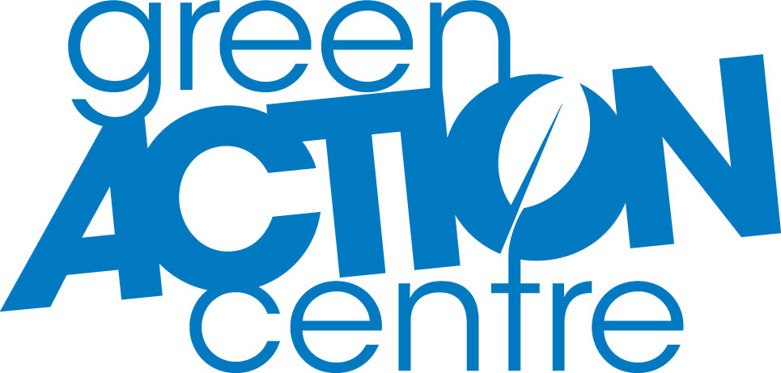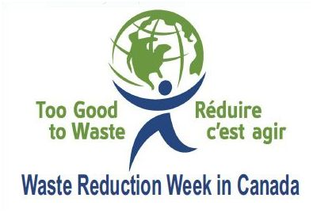

<Put Your Logo Here>

<Your City, Manitoba> <Month/Day/2012> – As a company, we are committed to conserving resources, protecting the environment and educating our employees.

Our decision to participate in the 2012 Waste Reduction Week shows that we recognize the generation of solid waste and the needless waste of water and energy resources as a global environmental problem. We also appreciate the richness & beauty of our diverse world and the importance of working toward ecological sustainability by conserving resources and curbing wasteful practices.

Our initiatives this year are: <tell us all about them. It would be good to have at least 2-3 things to highlight. You can also put this information as a subtitle in your headline>.

We are proud to declare October 15 -21, 2012 as Waste Reduction Week in our company.

**About Waste Reduction Week**

Waste Reduction Week (WRW) in Canada was developed in 2001 by a coalition of 13 recycling councils and sister organizations from across Canada and is delivered in Manitoba by Green Action Centre. The Program’s goal is to inform Canadians about the environmental and social ramifications of wasteful practices. WRW provides Canadians with information and ideas to reduce waste in all facets of daily living, creating solutions to the many environmental challenges we face.

###

Contact: <First & Last Name>

Tel: <area code, phone number>

Cell: <optional>

E-Mail: <your email address>

<Today’s Date>

**<Your Company > Recognizes Waste Reduction Week**

*We are committed toward environmental sustainability*

For Immediate Release